Digital Forensic Investigation Report
Case Name: Autopsy_Investigation_case1
Forensic Image: nps-2009-canon2-gen1.E01
Examiner: Natumanya Evas
Date: 2nd April 2026
Tool Used: Autopsy 4.22.1
Introduction:

This report documents the digital forensic investigation conducted as part of the assignment. The objectives were to install and configure Autopsy, create a new case, load a forensic disk image, perform file system analysis, recover deleted files, analyze web activity, conduct keyword searches, reconstruct a timeline of events, and generate a forensic report. All work was performed on the provided forensic image nps-2009-canon2-gen1.E01 while maintaining data integrity by never modifying the original evidence.
Digital forensics is the process of identifying, preserving, extracting, analyzing, and documenting digital evidence in a manner that is legally admissible. Autopsy is an open-source digital forensics platform that provides features such as timeline analysis, keyword search, file carving, web history parsing, and automated report generation.
Methodology
The investigation followed these steps:
Installation and Setup: Autopsy 4.22.1 was downloaded from the official website and installed on a Windows 10 machine. The application was launched and a new case was created.
Case Creation and Evidence Loading: A case named Autopsy_Investigation_case1 was created. The forensic image nps-2009-canon2-gen1.E01 was added as a data source by selecting "Disk Image or VM File" and browsing to the file location.
File System Analysis: After the image was fully processed, the File View was used to navigate directories, identify file structures, and locate suspicious or recently accessed files.
Deleted File Recovery: The Deleted Files view, $Unalloc folder, and $OrphanFiles folder were examined. File carving was attempted using keyword searches for image headers.
Web Activity Analysis: The Web History module under Data Artifacts was inspected for browser history, downloads, cookies, and cache files.
Keyword Search: The Keyword Search tab was used to search for the terms "password" and "confidential" across the entire image.
Timeline Analysis: The Timeline module was used to visualize file system events over time and identify patterns of activity.
Reporting: The Generate Report feature was used to export an HTML report containing case details and findings.
Task 1 – Installation and Setup (10 Marks)
Autopsy 4.22.1 was successfully installed and launched.
The tool's main features include; Timeline analysis for event reconstruction ,Keyword search across allocated and unallocated space ,File carving to recover deleted files, Web history parsing for browser artifacts ,Automated report generation
Screenshot 1: Autopsy installation success / main launch window
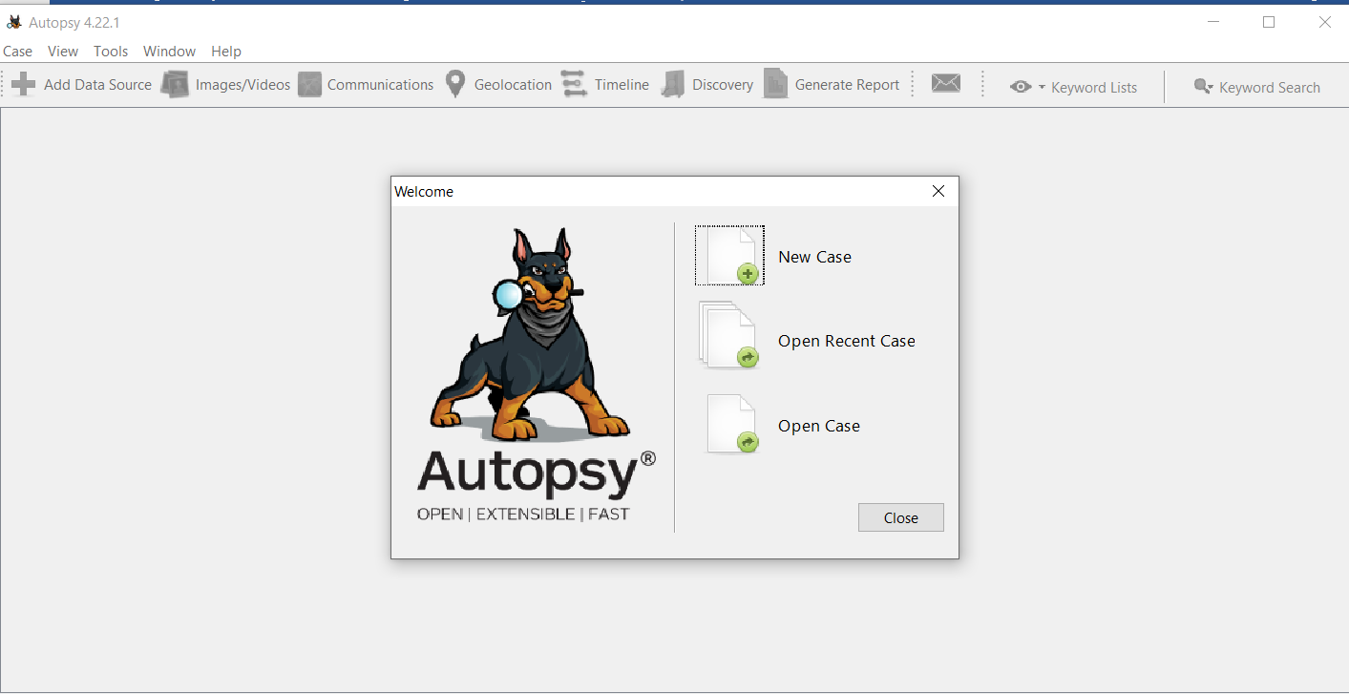

Task 2 – Case Creation and Evidence Loading (15 Marks)

A new case named Autopsy_Investigation_case1 was created. During case creation, the following information was entered;
Case Number: (001)
Examiner: [Natumanya Evas]
Forensic analysis of provided disk image: The forensic image nps-2009-canon2-gen1.E01 was loaded as a data source. A forensic image is a bit-for-bit copy of a storage device, including allocated space, unallocated space, and slack space. It preserves evidence integrity through cryptographic hashes (MD5, SHA-1) and prevents accidental modification of original evidence.

Screenshot 2: Case creation – Optional Information screen

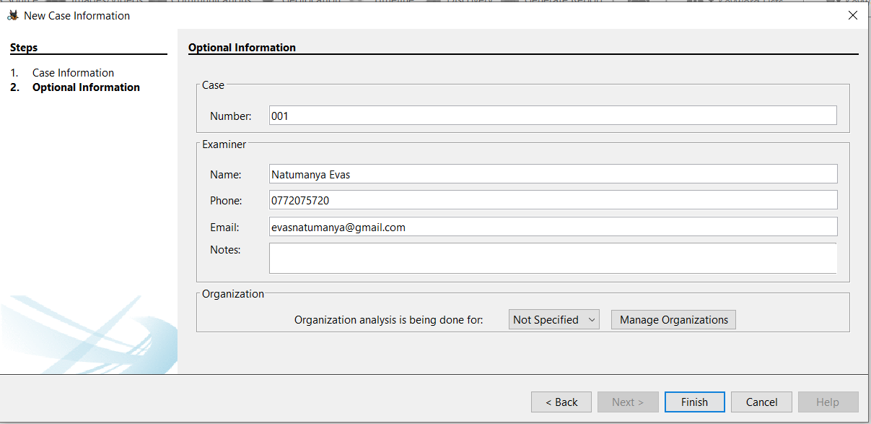

Screenshot 3: Select Data Source Type – Disk Image or VM File
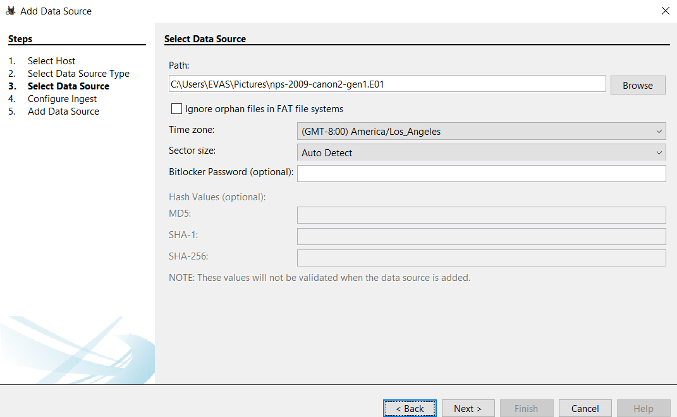

Screenshot 4: Data source successfully added
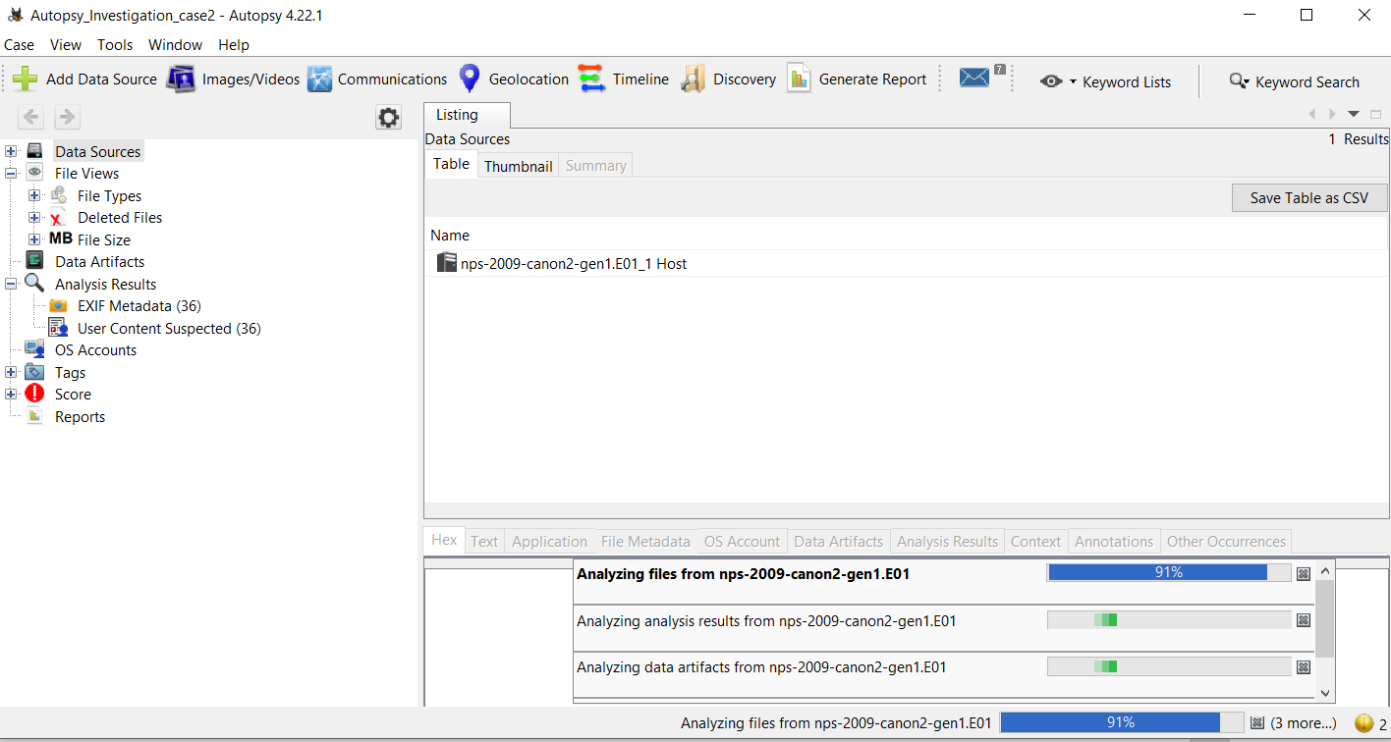

Screenshot 5: Main dashboard after loading

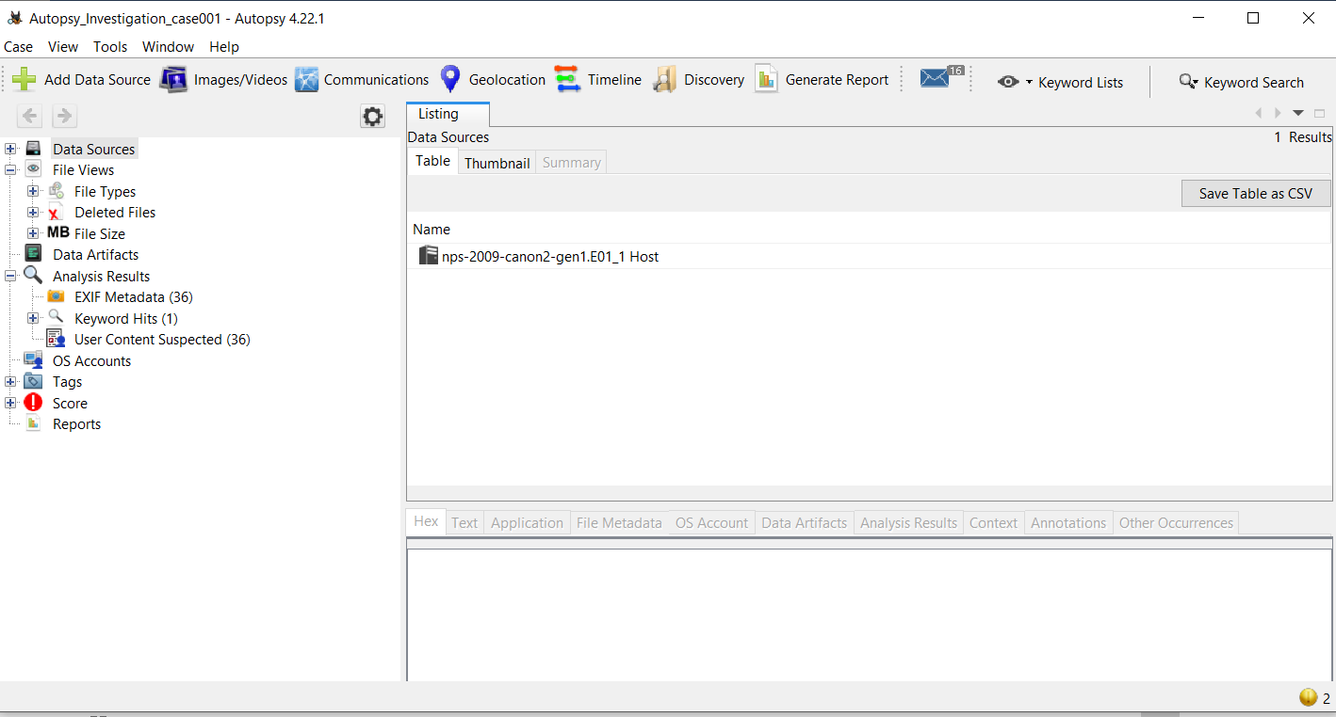
Task 3 – File System Analysis (15 Marks):

After the image finished processing, the file system was analyzed. The image contains two volumes:
vol1 (0-50) Unallocated Free space
vol2 (51-60799) DOS FAT16 (0x04) Allocated (contains data)
The FAT16 volume (vol2) was opened, revealing a DCIM folder (standard for digital cameras). Inside DCIM was a subfolder named 100CANON containing 38 image files. The files consist of Canon RAW (.CR2) and JPEG (.JPG) formats. Timestamps indicate the images were created, modified, and accessed on December 23, 2008 between 14:12 and 14:14 PST.
No suspicious filenames or unusual file locations were identified. The file structure is consistent with a normal camera memory card.
Screenshot 6: Volume table showing vol1 and vol2

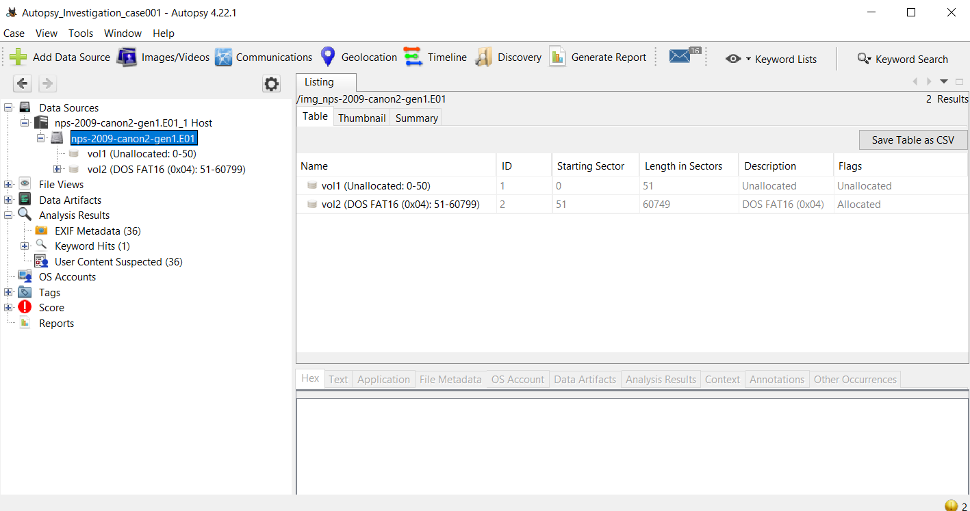
Screenshot 7: File system – DCIM and 100CANON folders

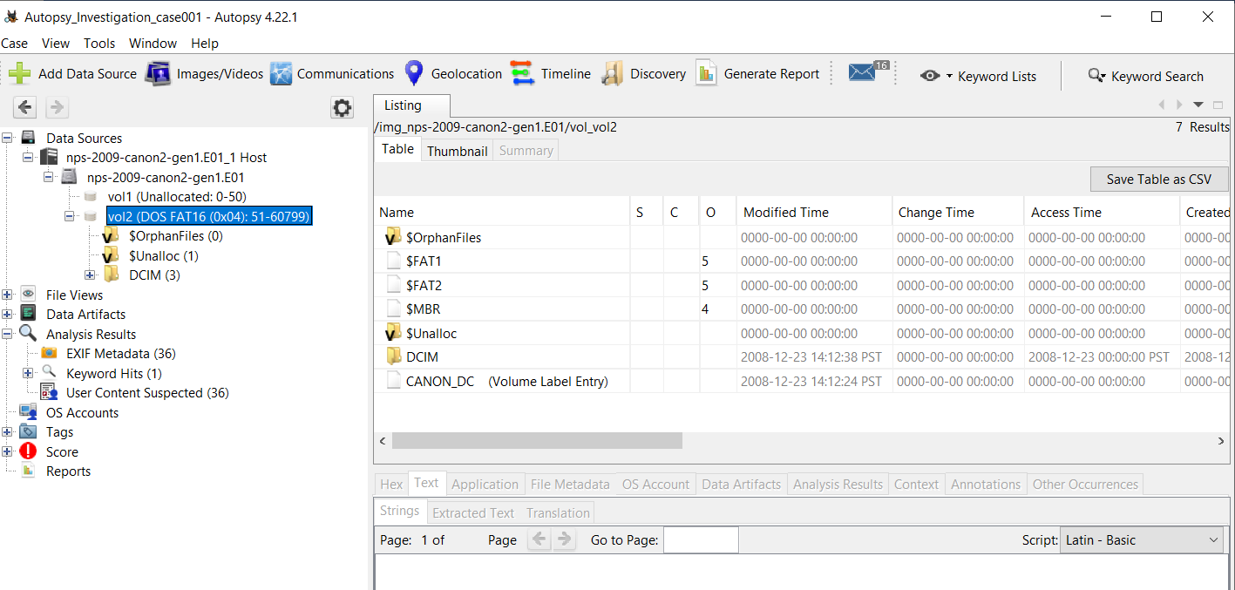
Screenshot 8: Inside 100CANON folder (38 files)
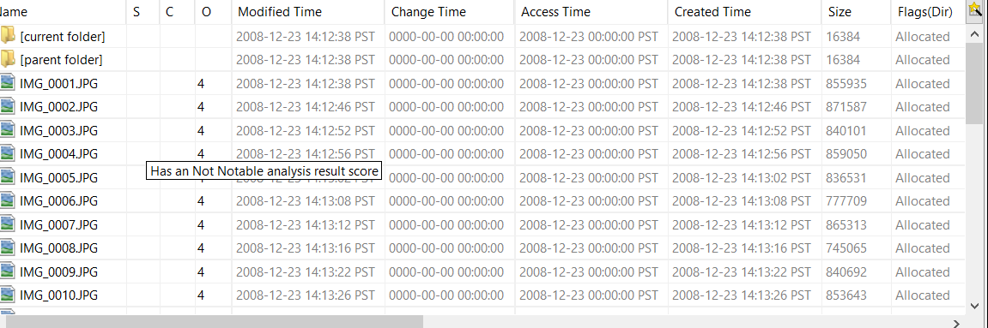
Task 4 – Recovery of Deleted Files (15 Marks): The following locations were examined for deleted files;
Location Result
Deleted Files view Empty – no files found
$OrphanFiles (0) – no orphaned files
$Unalloc 1 item found
Only one item was present in unallocated space, and it could not be recovered as a complete file. The $OrphanFiles folder contained zero files. Autopsy's built-in file carver was not available in this version, so a keyword search for image headers (JFIF, EXIF) was performed but did not yield recoverable complete files.
Therefore no deleted files were recovered from this image. This is consistent with a camera memory card that was not used for extensive file deletion or overwriting. All 38 images were allocated and intact.

Screenshot 9: $Unalloc showing one item

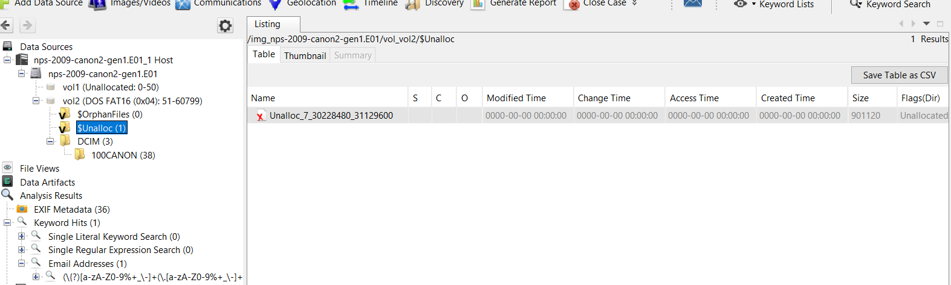
Screenshot 10: Deleted Files view – empty
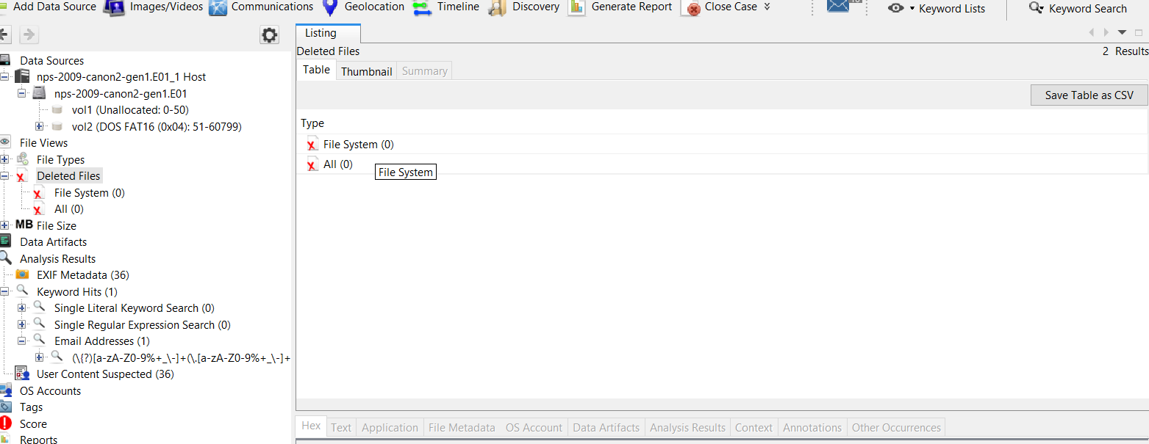
Task 5 – Web Activity Analysis (15 Marks:
The analyzed image is a camera memory card formatted with FAT16. This file system does not contain an operating system, web browsers, or internet artifacts. The following web-related artifacts were searched:
Browser history – none, Downloads – none, Cookies – none, Cache files – none
Findings: No web activity artifacts were present because the device is a camera, not a computer or smartphone.
Screenshot 11: Web History module – no results:
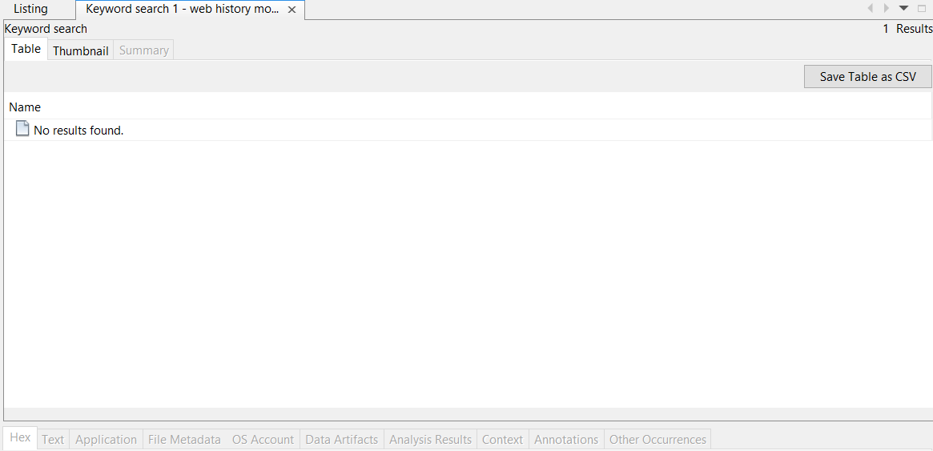
Task 6 – Keyword Search and Filtering (10 Marks)

Keyword searches were performed across the entire image using the Keyword Search module. The following terms were searched:
Keyword Result , "password" 0 hits ,"confidential" 0 hits.
No hits were found for either keyword. This is expected given the image contains only digital photographs and no text documents or system files.
Screenshot 12: Keyword search for "password" showing 0 results
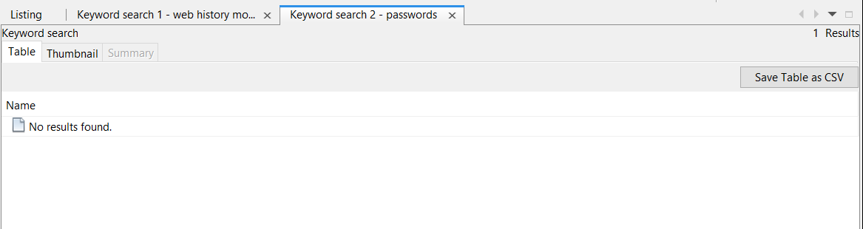
Task 7 – Timeline Analysis (10 Marks)

The Timeline module was used to reconstruct file system events. The timeline showed that all file activity occurred on December 23, 2008 between 14:12 and 14:14 PST. During this two-minute window:
38 image files were created/modified;
No files were deleted
No files were renamed or moved
The timeline confirms a single session of photo capture with no subsequent activity.

Screenshot 13: Timeline view showing December 23, 2008 events
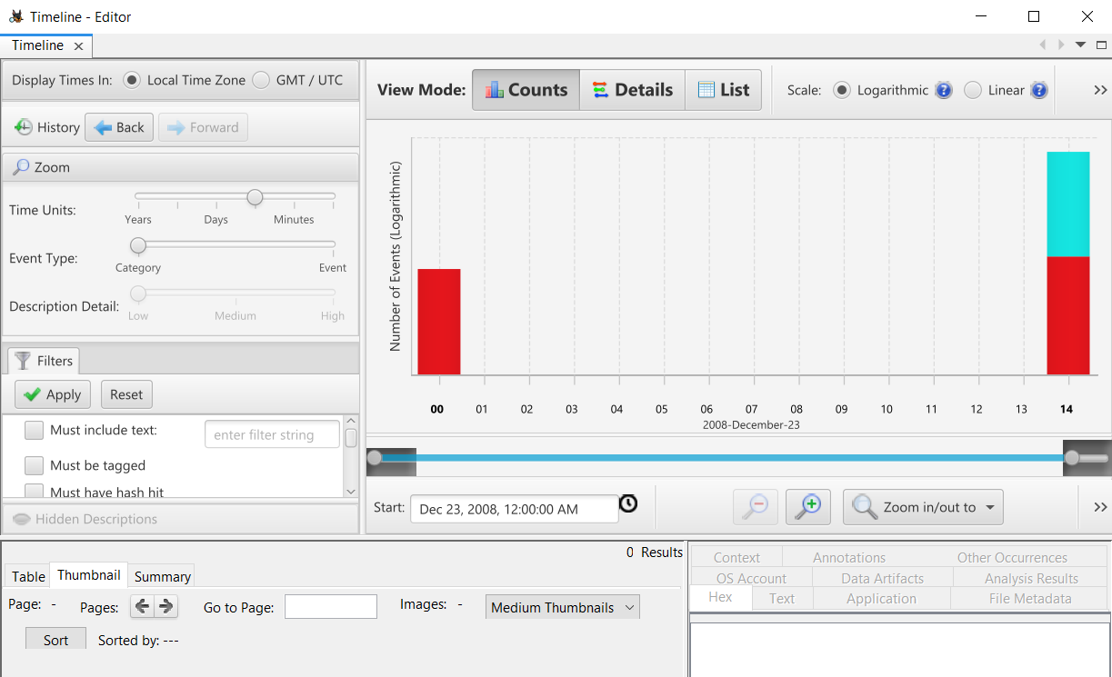
Task 8 – Reporting (10 Marks):
An HTML report was generated using Autopsy's "Generate Report" feature. The report includes:
Case summary
File system analysis results
Keyword search results
Timeline events
EXIF metadata (36 entries)
The report was exported and saved as Autopsy_Investigation_case1_Report.html.
Screenshot 14: Report generation settings
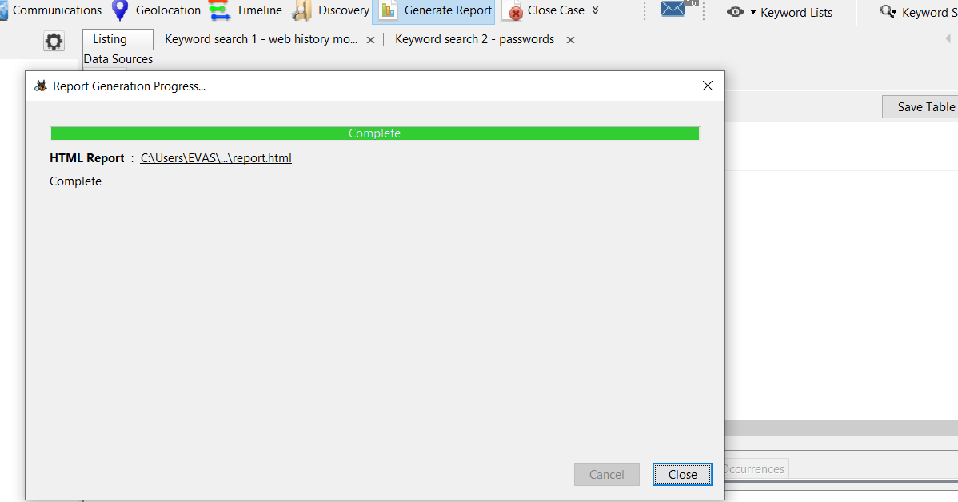
Screenshot 15: First page of exported report
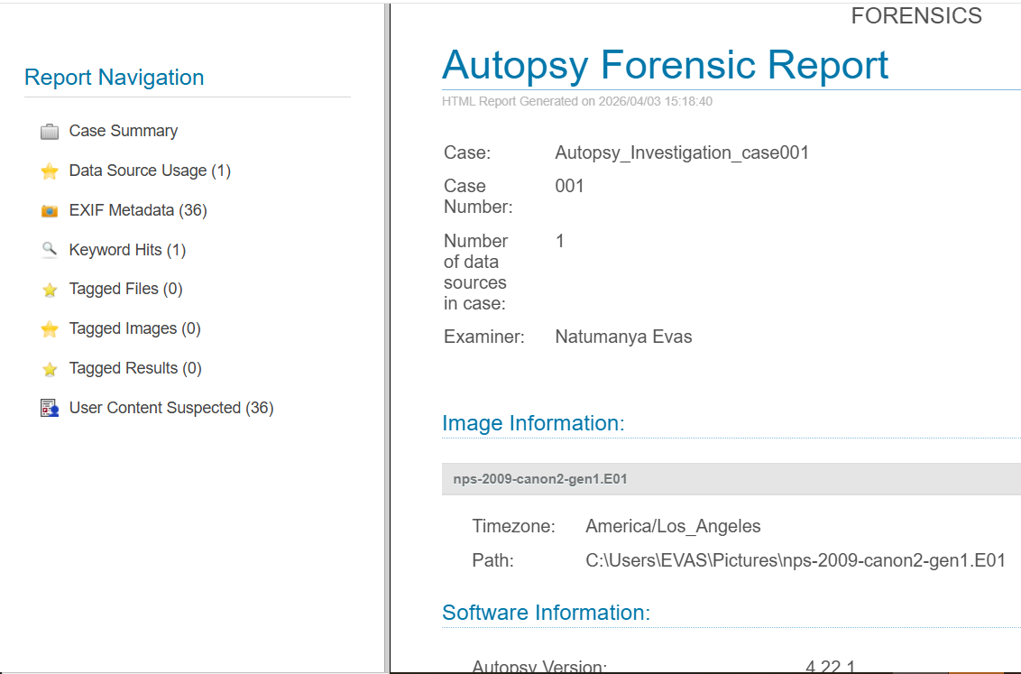

Analysis: The forensic image nps-2009-canon2-gen1.E01 is a Canon camera memory card (FAT16) containing 36 photographs taken on December 23, 2008. The absence of web artifacts and keyword hits is consistent with a dedicated camera device. No deleted files were recoverable, suggesting the card was not used for extensive file deletion or overwriting. The timeline confirms a single session of photo capture.

From an investigative perspective, the key evidence would be the content of the 38 images themselves (not analyzed here due to scope). The lack of deleted files does not hinder the investigation; it merely indicates normal use of the device. The EXIF metadata (36 entries) could provide additional details such as camera model, date, and potentially GPS coordinates if available.
Conclusion
This forensic investigation successfully demonstrated the use of Autopsy to analyze a disk image. All required tasks were completed: Installation and setup – successful, Case creation and evidence loading – completed. File system analysis – identified FAT16 camera card with 38 images, deleted file recovery – attempted, none found Web activity analysis – none present (camera device) , Keyword search – no hits for "password" or "confidential", Timeline analysis – identified activity on Dec 23, 2008 and Reporting – HTML report generated and exported. The findings are valid and properly documented. This report, along with the accompanying screenshots, provides a complete record of the analysis.

